Category - Global Skin Packaging Market
Market Size and Trends:
The Global Skin Packaging Market is estimated to be valued at USD 12.56 billion in 2026 and is expected to reach USD 17.21 billion by 2033, growing at a compound annual growth rate (CAGR) of 4.6% from 2026 to 2033. This growth reflects increasing demand for innovative packaging solutions that enhance product protection, sustainability, and consumer appeal within the cosmetic and personal care industries worldwide.
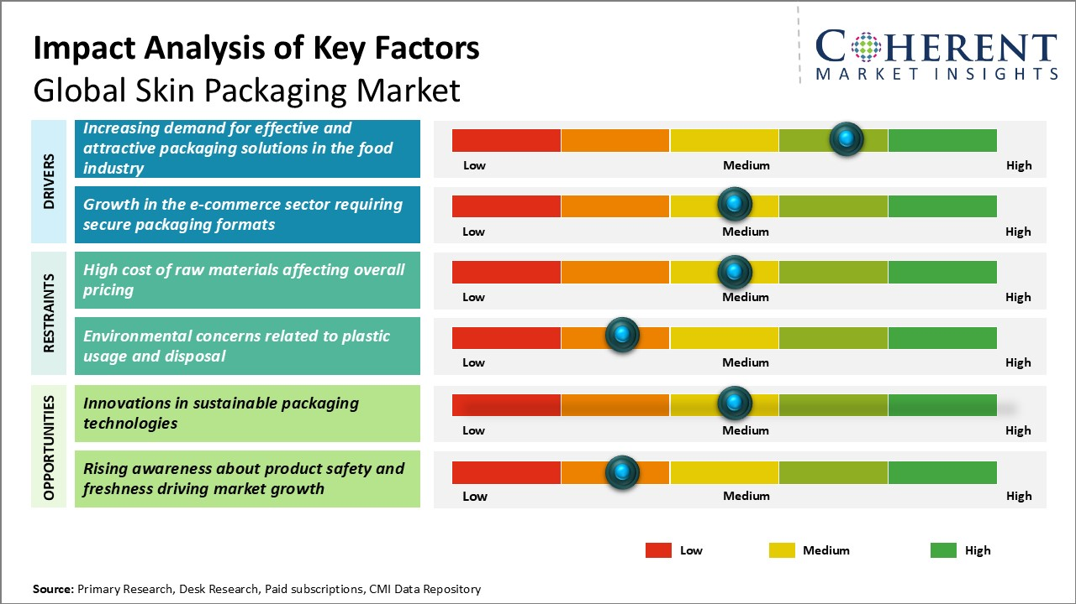
Key trends shaping the skin packaging market include the rising emphasis on eco-friendly and biodegradable materials, driven by consumer awareness and stringent regulatory frameworks. Additionally, advancements in smart packaging technologies, such as integrated anti-counterfeiting features and sustainable designs, are gaining prominence. Brands are also focusing on customization and aesthetic appeal to improve brand differentiation, fueling further market expansion in both developed and emerging economies.
Segmental Analysis:
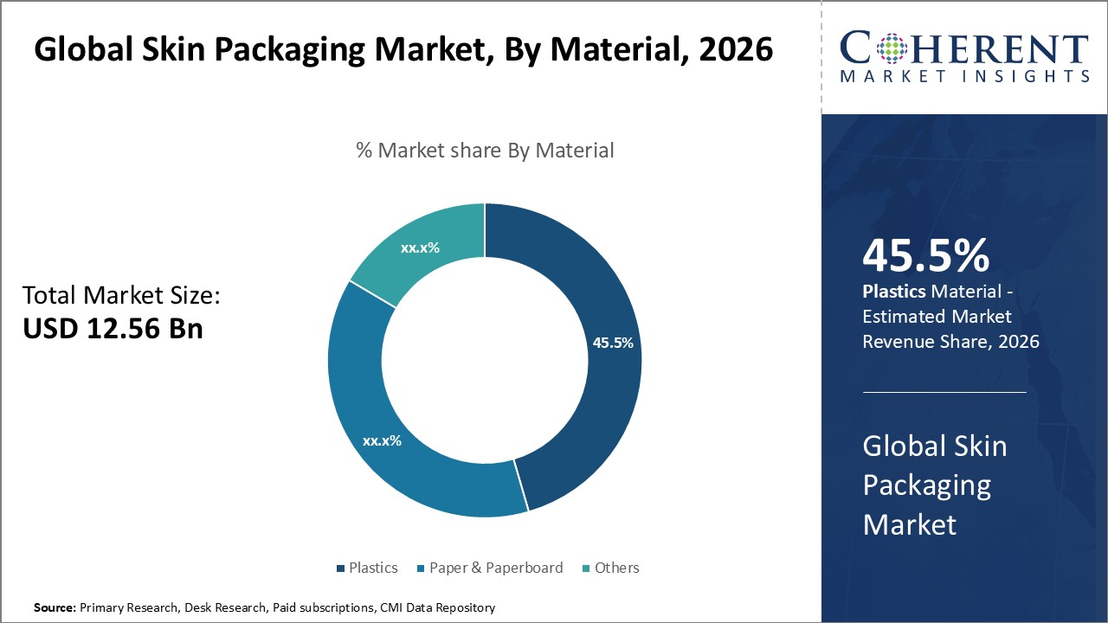

In terms of By Material, Plastics contributes the highest share of the market owning to its versatility and protective properties
The dominance of plastics in the global skin packaging market is driven primarily by its unmatched versatility and robustness, which cater effectively to the requirements of product protection and consumer convenience. Plastics offer excellent barrier properties that help in preserving the freshness and shelf life of packaged goods, especially in sectors such as food and medical devices where contamination prevention and hygiene are critical. The ability of plastics to form tight seals around products ensures minimal exposure to external factors like moisture, oxygen, and microbial invasions, thereby significantly enhancing product quality and safety.
Moreover, plastics are highly adaptable in terms of design and manufacturing, allowing for a range of packaging shapes and sizes that appeal to different product types and retail display needs. The flexibility in molding and thermoforming plastics enables skin packaging to precisely contour products, reducing material wastage while presenting products attractively at the point of sale. This adaptiveness is especially valuable for irregularly shaped items or those requiring tamper-evident packaging, which plastic materials can accommodate seamlessly.
Another driving factor is the cost efficiency plastics offer in large-scale production. Compared to alternatives such as paperboard or other materials, plastics provide a cost-effective solution through lower material and processing costs, as well as lighter weight which reduces shipping expenses. This economic advantage is significant for manufacturers seeking to optimize packaging while maintaining product integrity, especially in competitive consumer markets.
Sustainability concerns have prompted innovation in plastic materials as well, with bioplastics and recycled plastics gaining interest. These developments aim to maintain the functional benefits of plastics while addressing environmental impacts, thus ensuring the material’s continued relevance in a market increasingly influenced by ecological considerations. As manufacturers adopt such sustainable plastics, the appeal of plastics in skin packaging is further reinforced.
Lastly, regulatory support and technological advancements in plastic packaging – such as improved heat resistance, enhanced sealing methods, and compatibility with automated packaging systems – continue to boost the prevalence of plastics within the skin packaging sector. These enhancements streamline production and improve product performance, solidifying plastics as the preferred material in this rapidly evolving market.
---
Segment 2 – In terms of By Application, Food dominates the market driven by demand for enhanced product preservation and consumer convenience
Among the various applications of skin packaging, the food segment leads due to escalating consumer demands for freshness, safety, and extended shelf life. Skin packaging offers an ideal solution for food products by tightly sealing items onto a backing material, which prevents contamination, reduces oxidation, and limits moisture loss. This is particularly significant for perishable foods such as fresh produce, dairy, and prepared meals, where product integrity directly influences consumer satisfaction and brand reputation.
Consumer preferences have also shifted towards ready-to-eat and convenient food options, supporting the adoption of skin packaging. This packaging format enables easy handling, portion control, and extended storage without compromising food quality. Retailers benefit from improved product visibility since the transparent films used in skin packaging allow consumers to see the product clearly, increasing purchase confidence.
Another factor contributing to the growth of the food segment in skin packaging is the stricter regulatory environment around food safety standards. Skin packaging helps manufacturers comply with these regulations by providing tamper-evident and hygienic packaging solutions that minimize risk of contamination during transportation and storage. This is essential for processed foods, meat, fish, and seafood products where safety and traceability are paramount.
The food industry’s emphasis on sustainability is also impacting skin packaging trends. While plastics dominate, there is growing integration of recyclable or biodegradable materials in skin packaging tailored for food products, catering to environmentally conscious consumers and regulatory pressures to reduce packaging waste.
The versatility of skin packaging in preserving diverse food categories, from delicate fish and seafood to processed meats and cheeses, further reinforces its widespread adoption. Its ability to maintain texture, flavor, and appearance while extending freshness aligns perfectly with the complex requirements of the food supply chain.
In summary, the food segment’s leading share is propelled by skin packaging’s ability to enhance food preservation and safety, combined with increasing consumer demand for convenience and transparency in packaging. As food manufacturers and retailers prioritize product quality and sustainability, skin packaging remains a fundamental enabler of market growth in this critical application area.
Regional Insights:
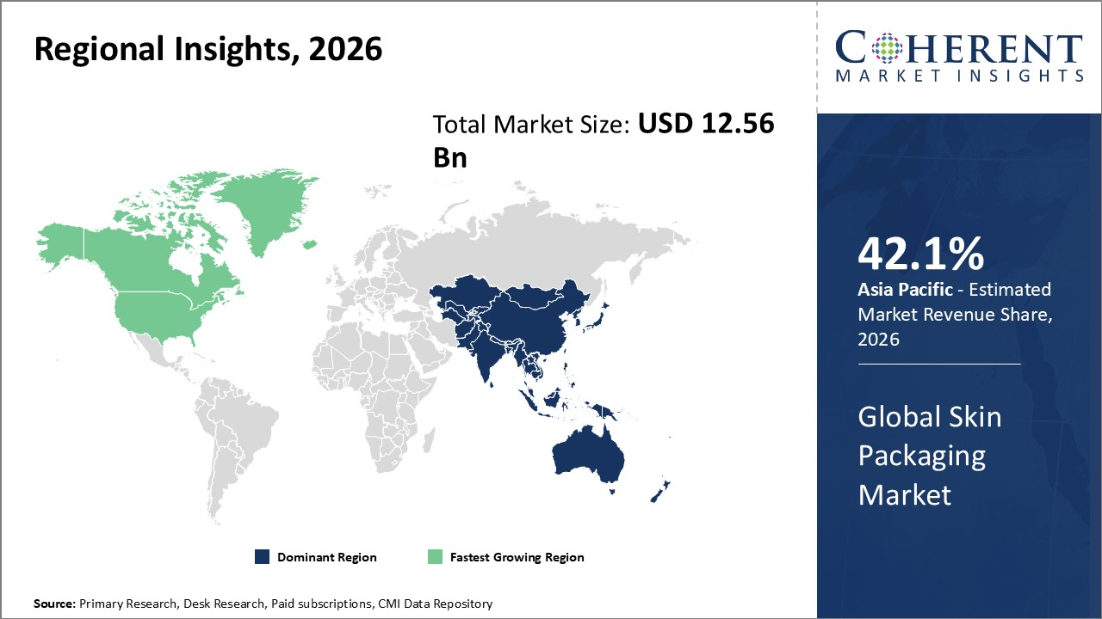

Regional Analysis:
Dominating Region: North America
In North America, the dominance in the Global Skin Packaging Market is attributed to a well-established healthcare infrastructure, robust presence of cosmetic and pharmaceutical companies, and advanced technological capabilities. The strong regulatory environment led by the FDA ensures high standards, driving demand for innovative and secure skin packaging solutions. Additionally, the region benefits from significant investments in R&D and sustainability initiatives aimed at reducing packaging waste. Leading companies such as Amcor, WestRock, and AptarGroup have played a vital role by introducing customizable, tamper-evident, and eco-friendly skin packaging products, reinforcing North America’s commanding position in the market.
Fastest-Growing Region: Asia Pacific
Meanwhile, the Asia Pacific exhibits the fastest growth in the skin packaging market driven by rapid urbanization, expanding middle-class populations, and increasing demand for personal care and pharmaceutical products. The region’s evolving regulatory frameworks and favorable government policies supporting manufacturing and exports have encouraged both international and local players to enhance production capacities. Countries like China, India, and South Korea have witnessed a surge in the entry of multinational corporations alongside thriving domestic manufacturers such as Nitto Denko, Uflex, and Guangdong Redboard, advancing innovative packaging technologies tailored to diverse market needs. Trade liberalization and development of organized retail are further accelerating market expansion in Asia Pacific.
Global Skin Packaging Market Outlook for Key Countries
United States
The United States market is highly competitive and innovation-driven, hosting numerous market leaders such as Amcor and WestRock that focus on high-quality, sustainable packaging solutions. Demand is buoyed by extensive pharmaceutical production and a mature cosmetics industry. Strict regulatory standards promote high safety and quality in skin packaging products, pushing companies toward greater efficiency and sustainability. The country’s emphasis on environmental compliance has accelerated the adoption of recyclable and biodegradable packaging materials in skin packaging.
China
China’s skin packaging market is marked by rapid industrial growth and increasing consumer demand for premium skincare and pharmaceutical products. The government’s supportive policies for manufacturing, coupled with improvements in infrastructure and technology adoption, have attracted investments from global packaging firms like Uflex and local innovators. The expanding e-commerce sector has also boosted demand for protective and attractive packaging solutions. Chinese companies are actively integrating automation and smart packaging technologies to cater to both domestic and export markets.
Germany
Germany continues to lead in Europe’s skin packaging market by leveraging its strong industrial base, stringent quality regulations, and commitment to sustainability. Well-established companies such as Koehler Group and Gerresheimer have pioneered eco-friendly and functional skin packaging designs, catering largely to pharmaceutical and cosmetic industries. The country’s emphasis on innovation and precision engineering ensures that products meet high standards, fostering adoption of advanced barrier films and tamper-evident features. Germany also benefits from strong export capabilities within the European market.
India
India’s skin packaging market is growing rapidly due to rising consumer spending, increasing awareness of healthcare and hygiene, and expanding pharmaceutical manufacturing capacities. Favorable government initiatives like Make in India and enhanced infrastructure are supporting local manufacturers and encouraging entry of multinational players like Uflex and Essel Propack. The country’s skincare and cosmetic market expansion drives demand for both cost-effective and premium packaging solutions. Innovation in flexible packaging and sustainable materials is gaining traction, supported by improving supply chain networks.
South Korea
South Korea’s skin packaging market is characterized by innovation and design excellence, influenced heavily by the country’s globally recognized cosmetics and skincare industry. Leading packaging companies such as Nitto Denko leverage advanced materials and cutting-edge technology to produce functional and aesthetically appealing packaging. Consumer preference for eco-friendly and convenient packaging formats has led to the adoption of lightweight, recyclable, and multi-functional skin packaging solutions. South Korea’s government policies encouraging green manufacturing practices further stimulate innovation and market growth within this region.
Competitive Landscape:
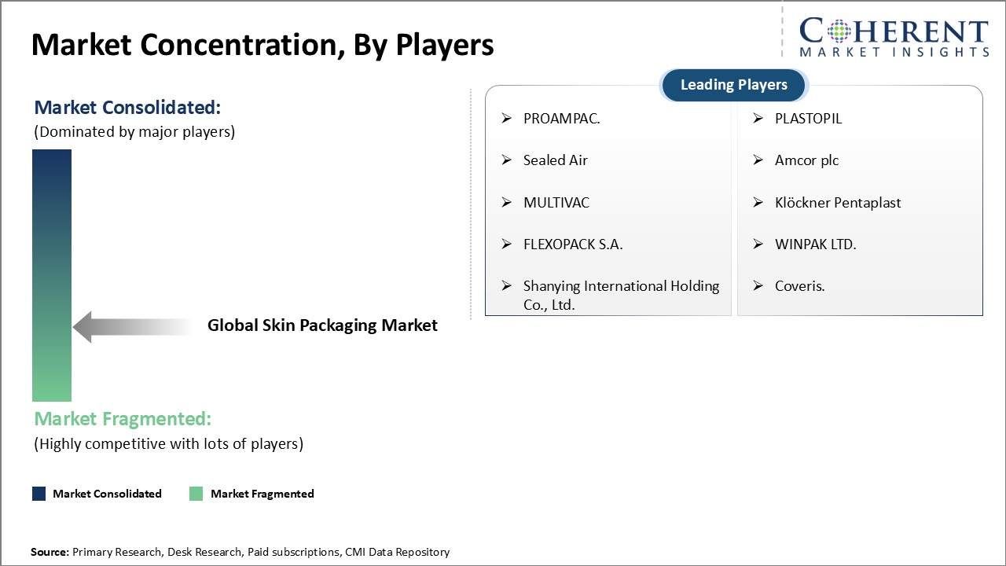

The competitive landscape of the global skin packaging market is characterized by a dynamic interplay among established giants, mid-level companies, and small-scale players, each adopting distinct strategies to secure and expand their market share. Established industry leaders heavily invest in research and development (R&D) to drive innovation and develop high-performance packaging solutions that meet evolving consumer demands and regulatory standards. These companies prioritize creating products that offer superior protection, sustainability, and aesthetic appeal, thereby differentiating themselves from competitors. Furthermore, they actively form strategic partnerships with major industry players, including original equipment manufacturers (OEMs), to enhance their product offerings and strengthen their market positioning. Such alliances not only facilitate access to new technologies but also enable joint ventures that can leverage complementary strengths. To further consolidate their leadership, these players expand their footprints on a global scale by broadening distribution networks and penetrating emerging markets, which present lucrative growth opportunities driven by increasing skincare consumption and urbanization.
Mid-level players in the skin packaging market adopt strategies centered around delivering cost-effective yet reliable packaging solutions that strike a balance between quality and affordability. This approach allows them to effectively target price-sensitive consumer segments, particularly in developing economies where demand for skincare products is rising rapidly. By focusing on efficient production processes and material optimization, these companies manage to keep costs low without significantly compromising product performance or aesthetics. To enhance their market presence and capabilities, mid-level firms engage in collaborations and partnerships aimed at technology transfer, capacity expansion, and market penetration. Such alliances help them scale operations, improve manufacturing efficiencies, and gain access to newer distribution channels. Additionally, these collaborations often support product diversification efforts, enabling mid-tier companies to offer a broader portfolio that appeals to various customer preferences and regulatory requirements, thereby solidifying their position in competitive regional markets.
Small-scale players in the global skin packaging market carve out their niches by emphasizing specialized features or highly innovative packaging concepts that differentiate them from larger competitors. These companies often leverage cutting-edge technologies such as smart packaging, biodegradable materials, and customized designs to address specific market needs or sustainability trends, thereby appealing to a targeted consumer base seeking unique or eco-friendly solutions. Due to limited resources, small-scale manufacturers typically focus on regional or local market segments and work to build alliances with startups, local manufacturers, or boutique brand owners to increase visibility and gain market entry. These partnerships facilitate knowledge exchange, resource sharing, and collaborative product development that can amplify their competitive edge within defined geographies. By championing innovation and regional relevance, small players maintain a resilient presence in the market, often acting as incubators for breakthrough packaging technologies that can influence l
Key Developments:
- In April 2024, Klockner Pentaplast launched what it claimed was the first food packaging tray made entirely from 100% recycled PET (rPET) derived entirely from trays. This innovation is part of the company’s Tray2Tray initiative, which aims to create a closed-loop system for PET recycling by recovering and reusing PET from used food trays. This development demonstrates the potential for significant advancements in sustainable packaging, reducing waste, and promoting a better economy.

Key Takeaways from Analyst
In April 2024, Klockner Pentaplast launched what it claimed was the first food packaging tray made entirely from 100% recycled PET (rPET) derived entirely from trays. This innovation is part of the company’s Tray2Tray initiative, which aims to create a closed-loop system for PET recycling by recovering and reusing PET from used food trays. This development demonstrates the potential for significant advancements in sustainable packaging, reducing waste, and promoting a better economy.

Market Report Scope - After Analyst View
Global Skin Packaging Market
Report Coverage | Details
Base Year | 2025 | Market Size in 2026: | USD 12.56 Bn
Historical Data For: | 2020 To 2024 | Forecast Period: | 2026 To 2033
Forecast Period 2026 To 2033 CAGR: | 4.60% | 2033 Value Projection: | USD 17.21 Bn
Geographies covered: | North America: U.S., Canada  Latin America: Brazil, Argentina, Mexico, Rest of Latin America  Europe: Germany, U.K., Spain, France, Italy, Russia, Rest of Europe  Asia Pacific: China, India, Japan, Australia, South Korea, ASEAN, Rest of Asia Pacific  Middle East: GCC Countries, Israel, Rest of Middle East  Africa: South Africa, North Africa, Central Africa
Segments covered: | By Material: Plastics , Paper & Paperboard , Others  By Application: Food (Meat, Fish and Seafood, Processed Food, Cheese), Industrial Goods , Medical Devices , Durable Consumer Goods
Companies covered: | PROAMPAC., PLASTOPIL, Sealed Air, Amcor plc, MULTIVAC, Klöckner Pentaplast, FLEXOPACK S.A., WINPAK LTD., Shanying International Holding Co., Ltd., Coveris.
Growth Drivers: | Increasing demand for effective and attractive packaging solutions in the food industry  Growth in the e-commerce sector requiring secure packaging formats
Restraints & Challenges: | High cost of raw materials affecting overall pricing  Environmental concerns related to plastic usage and disposal

Market Driver - Increasing demand for effective and attractive packaging solutions in the food industry
Rising Demand for Effective and Attractive Packaging Solutions in the Food Industry
The food industry is experiencing a significant shift towards packaging solutions that not only ensure product safety and freshness but also enhance visual appeal to attract increasingly discerning consumers. Skin packaging has emerged as a preferred option due to its ability to tightly seal food products, preventing contamination and extending shelf life without the need for excessive materials, which aligns with sustainability goals. Additionally, the transparent and form-fitting nature of skin packaging allows consumers to clearly view the product, boosting trust and influencing purchase decisions. Food manufacturers and retailers are continuously seeking packaging options that combine functionality with aesthetic appeal to differentiate their products in a crowded marketplace. This demand is further amplified by the growth of ready-to-eat and fresh food segments, which require packaging that maintains quality while offering convenience. Consequently, the desire for innovative, secure, and visually compelling packaging solutions is driving the expansion of skin packaging applications in the food sector.

Market Challenge - High cost of raw materials affecting overall pricing
Opportunity: Innovations in Sustainable Packaging Technologies
The global skin packaging market presents a significant opportunity driven by rapid advancements in sustainable packaging technologies. As environmental concerns intensify and regulatory pressures mount worldwide, both consumers and manufacturers are increasingly prioritizing eco-friendly packaging solutions. Innovations such as biodegradable films, compostable materials, and recyclable laminates are gaining traction, enabling skin packaging to reduce environmental impact without compromising product protection or shelf appeal. Moreover, the integration of bio-based polymers derived from renewable resources offers a promising alternative to traditional petroleum-based plastics, aligning with the growing demand for circular economy principles. These sustainable technologies not only address the critical issue of plastic waste management but also help companies enhance brand reputation by demonstrating corporate social responsibility. Industry players investing in R&D for such innovations can capitalize on shifting consumer preferences that favor green packaging, especially in sectors like food, pharmaceuticals, and personal care where skin packaging is widely used. Additionally, collaboration between raw material suppliers, packaging manufacturers, and end-users is fostering the development of customized sustainable solutions tailored to diverse product requirements. This transformational trend is expected to open new avenues in the skin packaging market, creating differentiation opportunities and driving long-term growth by meeting the dual challenge of sustainability and functionality.
Frequently Asked Questions:
What will be the CAGR of Global Skin Packaging Market?
The CAGR of Global Skin Packaging Market is projected to be 4.60% from 2026 to 2033.

What are the major factors driving the Global Skin Packaging Market growth?
Increasing demand for effective and attractive packaging solutions in the food industry and Growth in the e-commerce sector requiring secure packaging formats are the major factor driving the growth of Global Skin Packaging Market.

What are the key factors hampering growth of the Global Skin Packaging Market?
High cost of raw materials affecting overall pricing and Environmental concerns related to plastic usage and disposal are the major factor hampering the growth of Global Skin Packaging Market.

Which is the leading Material in the Global Skin Packaging Market?
In terms of Material, Plastics, estimated to dominate the market revenue share 2026.

Which are the major players operating in the Global Skin Packaging Market?
PROAMPAC., PLASTOPIL, Sealed Air, Amcor plc, MULTIVAC, Klöckner Pentaplast, FLEXOPACK S.A., WINPAK LTD., Shanying International Holding Co., Ltd., Coveris. are the major players.

Which region will lead the Global Skin Packaging Market?
Asia Pacific is expected to lead the Global Skin Packaging Market.
Market Segmentation
Material Insights (Revenue, USD, 2020 - 2033)
- Plastics
- Paper & Paperboard
- Others
Application Insights (Revenue, USD, 2020 - 2033)
- Food
- Meat
- Fish and Seafood
- Processed Food
- Cheese
- Industrial Goods
- Medical Devices
- Durable Consumer Goods

Regional Insights (Revenue, USD, 2020 - 2033)
- North America
- U.S.
- Canada
- Latin America
- Brazil
- Argentina
- Mexico
- Rest of Latin America
- Europe
- Germany
- U.K.
- Spain
- France
- Italy
- Russia
- Rest of Europe
- Asia Pacific
- China
- India
- Japan
- Australia
- South Korea
- ASEAN
- Rest of Asia Pacific
- Middle East
- GCC Countries
- Israel
- Rest of Middle East
- Africa
- South Africa
- North Africa
- Central Africa

Key Players Insights
- PROAMPAC.
- PLASTOPIL
- Sealed Air
- Amcor plc
- MULTIVAC
- Klöckner Pentaplast
- FLEXOPACK S.A.
- WINPAK LTD.
- Shanying International Holding Co., Ltd.
- Coveris.

